1. In last lecture, theoretically, we discussed about Spring IoC Container.
2. Let’s discuss with practical example.
3. 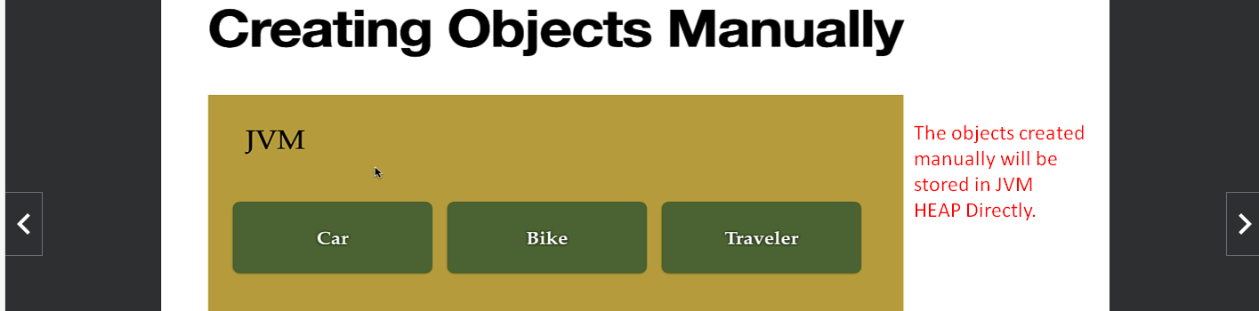
4. 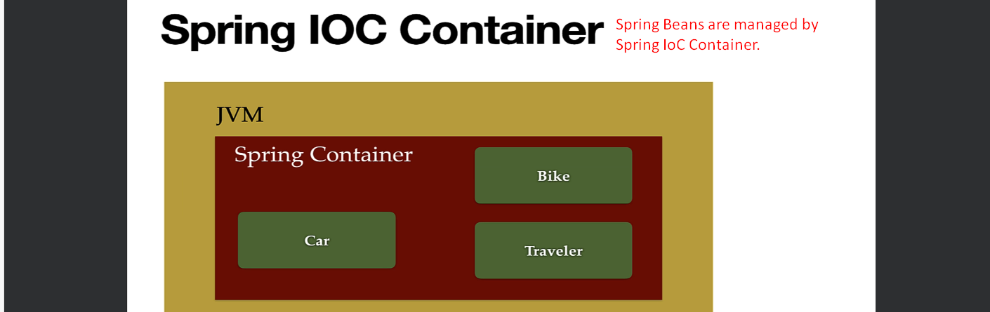
5. **Configuration Metadata**.
6. 
7. 3 kinds of Configurations.
   1. XML Based.
   2. Annotation Based.
   3. Java Based.   
      Many times, most of the developers prefer mixture of Annotation based and Java Based Configuration.
8. 
9. 
10. 